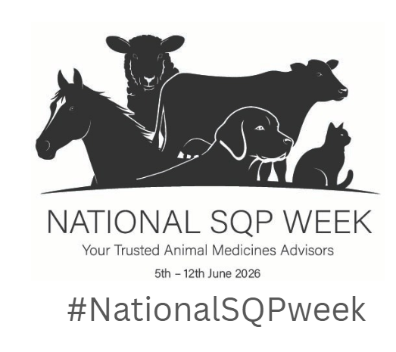
Newsletter / email copy: Please adapt to suit your organisation’s activities

Announcing the first ever National SQP Week!
The first ever National SQP Week is happening 5–12 June 2026 — a nationwide celebration of the vital role that Suitably Qualified Persons (SQPs), also known as Animal Medicines Advisors, play in protecting the health and wellbeing of pets, horses, livestock and birds across the UK.
SQPs are highly trained animal medicines advisors who provide essential guidance to millions of owners every year, prescribing, dispensing and supplying medicines ensuring animals get the right treatments safely and responsibly. As a nation of animal lovers, this is a role that rightly deserves to be celebrated for the positive impact it has on animal wellbeing.
We’ve got some great plans for the week including (personalise to suit your organisation) XXXXXXXXXXXXXXXXXXXXX.
Join us as we shine a spotlight on their expertise and the difference they make. #NationalSQPweek

Suggested content which can be adapted for use in a blog: Please adapt to suit your organisation

First ever National SQP Week – 5–12 June 2026 #NationalSQPweek
The UK’s first ever National SQP Week will take place from 5–12 June 2026, marking a major milestone for the Suitably Qualified Person (SQP) profession — also known as Animal Medicines Advisors. The week-long campaign aims to celebrate and raise awareness of the vital role SQPs play in safeguarding the health and wellbeing of pets, livestock, birds and horses across the UK.
National SQP Week has been announced jointly by the three industry regulators — AMTRA, Vetpol and VetSkill — who recognise the need to elevate public and professional understanding of SQP expertise. Their call to action follows an industry survey highlighting that many animal owners, and even some working in the veterinary and wider animal health sectors, are still unaware of the depth of training and knowledge held by SQPs.
SQPs are highly qualified professionals who can prescribe, dispense and supply certain animal medicines, provide trusted, accessible advice on animal medicines and wider welfare all of which support many millions of owners of pets, livestock, horses and birds, every year.
A recent industry survey revealed that many people who interact with SQPs don’t fully understand their expertise — or the benefits they can bring due to their essential role in improving nationwide animal health.
National SQP Week represents an exciting opportunity to shine a spotlight on a profession that contributes significantly to responsible animal medicine use and improved welfare outcomes. By taking part, animal owners and industry partners alike can help champion the role of SQPs and ensure their expertise is recognised, appreciated, and fully utilised across all sectors.
#NationalSQPweek
(Add in details specific to your organisation which reflects how you work with SQPs and the positive impact they have. You can also add information about what you are doing to celebrate and champion SQPs during National SQP Week).

