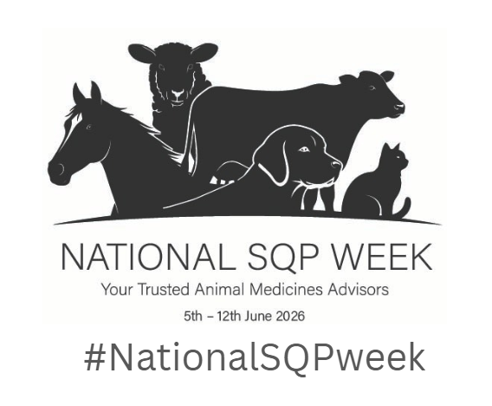
National SQP Week – pre-written social media posts
Please feel free to adapt these to suit your organisation and your National SQP Week activities. The words below are a guide only.
As well as these suggested posts, we encourage you to actively share your own pictures and content supporting the campaign. This might be a picture of your SQP team at work or a short video talking about SQPs and why the role is so important. Always use the campaign hashtag: #NationalSQPweek

Don’t forget you can also change your social media profile picture to the campaign logo for the week – the image you need is in the toolkit.
General posts:
📣 Announcing the first ever National SQP Week!
The first ever National SQP Week is happening 5–12 June 2026 — a nationwide celebration of the vital role that Suitably Qualified Persons (SQPs), also known as Animal Medicines Advisors, play in protecting the health and wellbeing of pets, horses, livestock and birds across the UK.
SQPs are highly trained animal medicines advisors who can prescribe, dispense and supply certain animal medicines and provide essential guidance to millions of owners every year, ensuring animals get the right treatments safely and responsibly. As a nation of animal lovers, this is a role that rightly deserves to be celebrated for the positive impact it has on animal wellbeing.
We’ve got some great plans for the week including XXXXXXXXXXXXXXXXXXXXX.
Join us as we shine a spotlight on their expertise and the difference they make.
#NationalSQPweek

🐶🐑🐴 Why National SQP week matters
Suitably Qualified Persons (SQPs) – also known as Animal Medicines Advisors, support responsible animal medicine use and promote better welfare. To achieve SQP status, individuals must complete an accredited qualification and then ongoing CPD to remain registered.
They can prescribe and supply certain animal medicines.
National SQP Week (5–12 June 2026) is a chance to highlight the trusted, knowledgeable advice SQPs provide every day.
Support the week, spread the word, and help more owners benefit from SQP expertise.
#NationalSQPweek

Suitably Qualified Persons (SQPs) are qualified and regulated professionals who give safe, practical, and personalised advice on animal medicines and wider welfare. They can prescribe and supply certain animal medicines. Their knowledge helps the owners of pets, livestock, horses and birds to make informed choices about the health and welfare of their animals. To mark the first ever National SQP Week, we’re celebrating the huge contribution SQPs make across all sectors and in all the places they work, from pet stores to farm retailers to veterinary practices.
Pop in and speak to an SQP to discover how they can support the health of your animals.
#NationalSQPweek

Suitably Qualified Persons (SQPs) play a crucial role in the UK’s One Health approach, offering trusted advice that supports responsible medicine use and better welfare outcomes. As we head towards the first ever National SQP Week, we’re proud to stand with AMTRA, Vetpol, and VetSkill in recognising and celebrating the profession. (add in details of your activities here)
#NationalSQPweek
Get ready to support the first ever National SQP Week
We’re gearing up for National SQP Week (5–12 June 2026) — and we want YOU to be part of it! Suitably Qualified Persons (SQPs) also known as Animal Medicines Advisors are qualified and regulated professionals who give safe, practical, and personalised advice on animal medicines and wider welfare.
(add in details of your activities here and how you want people to get involved)
Mark your calendars and start planning how you’ll help highlight the brilliant work of SQPs across the UK.
#NationalSQPweek
How SQPs support you and your animals
Every day, Suitably Qualified Persons (SQPs) also known as Animal Medicines Advisors, provide trusted advice on parasite control, worming, flea & tick medicines, nutrition and much more — helping keep your pets, horses and livestock healthy.
Yet many people don’t realise the depth of training and expertise behind the SQP role. SQPs are highly qualified professionals, dedicated to helping owners make the best health and welfare choices for their animals.
That’s exactly why National SQP Week has been launched — to celebrate and recognise their contribution.
#NationalSQPweek

🎉 Join our celebrations to mark National SQP Week
We’re proud to support National SQP Week, celebrating the knowledge, passion and dedication of Suitably Qualified Persons (SQPs) also known as Animal Medicines Advisors, right across the UK. Whether you’re a pet owner, farmer or horse owner, your SQP is here to support you with expert, friendly advice backed by recognised training and accreditation. Let’s spread the word and show our appreciation of this vital role.
#NationalSQPweek
Pre-written posts to use alongside some of the graphics.
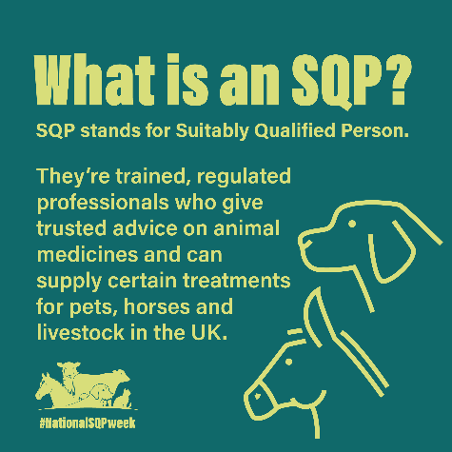
Suggested copy to go with the above graphic:
Ever wondered what an SQP actually is and does?
A Suitably Qualified Person (SQP) is a trained, regulated Animal Medicines Advisor who offers trusted guidance and can legally supply certain medicines for pets, horses and livestock across the UK.
They play a key role in supporting responsible animal health and medicine use — every single day.
Let’s shine a spotlight on the expertise behind the title this National SQP Week.
#NationalSQPweek #AnimalHealth #SQP #OneHealth

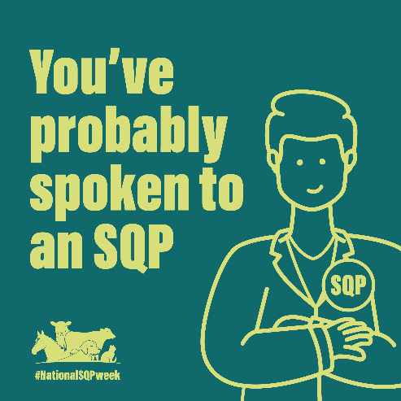
If you’ve ever asked for advice on worming, flea or tick treatments…you’ve probably spoken to a Suitably Qualified Person (SQPs) without even realising it! SQPs, also known as Animal Medicines Advisors, are often the first point of contact for owners with animal health queries for their pets, livestock, horses and birds, offering trusted guidance that helps owners make informed decisions.
This National SQP Week, let’s celebrate the experts behind those everyday conversations.
#NationalSQPweek #PetCare #HorseCare #LivestockHealth #SQPs

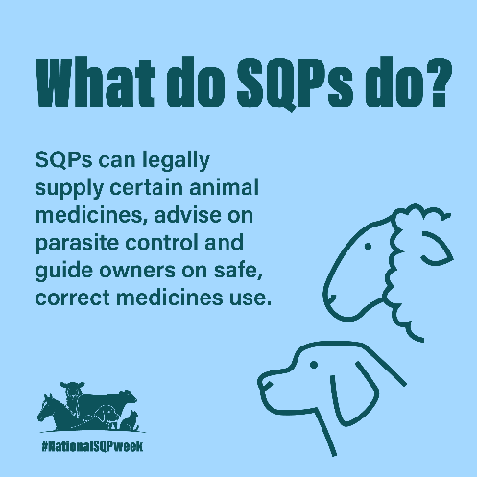
Suitably Qualified Persons (SQPs) also known as Animal Medicines Advisors, support animal health in so many ways. They can legally supply specific animal medicines, provide tailored parasite control advice, and guide owners on safe, responsible treatment use.
Their high level of knowledge, qualification and training helps ensure animals get the right products and owners are given advice on correct, safe and responsible use of those medicines. This National SQP Week, let’s celebrate that expertise.
#NationalSQPweek #AnimalHealthProfessionals #SQPAdvice #ResponsibleCare

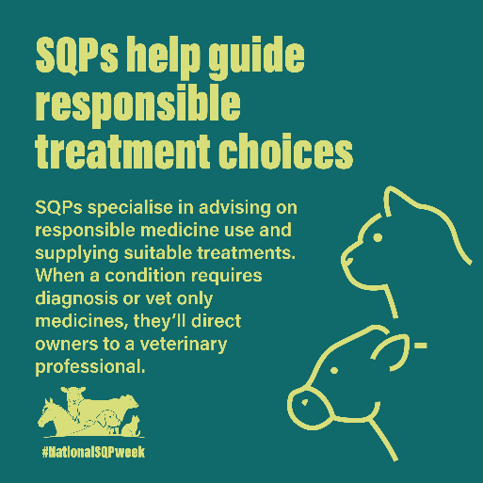
SQPs don’t just supply medicines — they help prevent problems before they start.
Through tailored advice, good husbandry guidance and effective parasite control planning, SQPs support owners in keeping animals healthy for the long-term.
This National SQP Week, we’re celebrating their vital role in proactive, responsible animal care.
#NationalSQPweek #PreventativeCare #AnimalWelfare #SQP

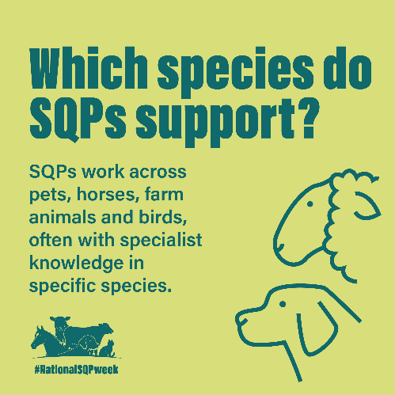
Suitably Qualified Persons (SQPs) also known as Animal Medicines Advisors, work across a huge range of species — pets, horses, farm animals and birds.
Many specialise in a particular species too, meaning owners get tailored, informed advice from a highly trained SQP.
Their knowledge helps ensure responsible medicine use and better animal welfare. This National SQP Week, let’s celebrate that expertise!
#NationalSQPweek #AnimalHealth #SpeciesSpecialists #SQPCommunity

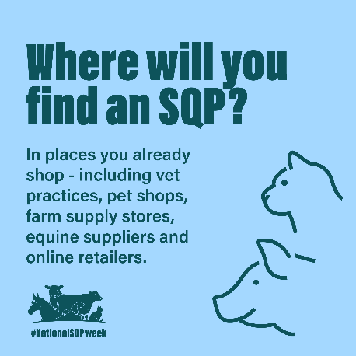
Whether you’re a pet, horse or livestock owner, you might speak to a Suitably Qualified Person (SQP - also known as Animal Medicines Advisors) more often than you think!
SQPs can be found in places you already shop — from vet practices and pet shops to farm supply stores, equine retailers and online platforms.
Wherever you buy animal health products, there’s likely an SQP ready to give trusted advice. This National SQP Week, let’s celebrate that expertise and the importance of this role in supporting owners to keep animals healthy.
#NationalSQPweek #AnimalCare #PetHealth #EquineCare #LivestockCare #PetCare

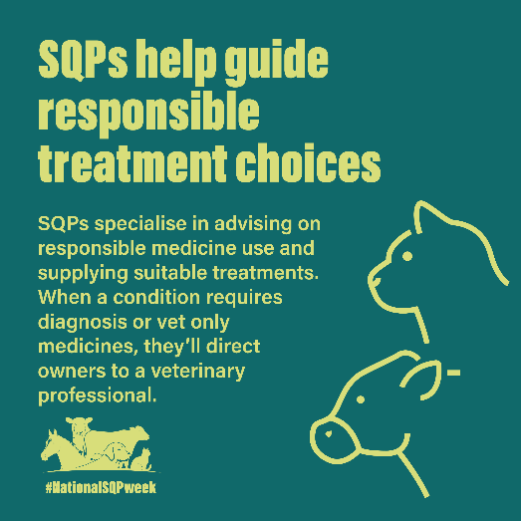
Suitably Qualified Persons (SQPs) also known as Animal Medicines Advisors, do more than recommend products — they guide responsible treatment choices.
Their high level of training and qualification means they can advise on safe medicine use and suggest suitable options. And when an animal needs a diagnosis or a vet-only medicine, they’ll make sure owners are directed to a vet.
It’s all about protecting welfare and making sure animals get the right care and advice. Raising awareness of the important role SQPs have in helping safeguard the wellbeing of animals is exactly why National SQP Week has been created. Join us in celebrating the fantastic job SQPs do in caring for animals.
#NationalSQPweek #ResponsibleMedicineUse #AnimalWelfare #animalmedicines #SQPAdvice

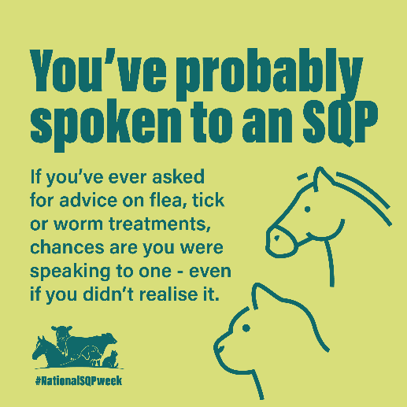
You’ve probably spoken to an SQP
If you’ve ever asked for advice on flea, tick or worm treatments, chances are you were speaking to a Suitably Qualified Person (SQP) also known as Animal Medicines Advisors — even if you didn’t realise it. They’re often the person helping you choose the right treatment to keep your animals healthy. This National SQP Week, let’s celebrate that expertise and the importance of this role in supporting owners to keep animals healthy.
#NationalSQPweek #AnimalCare #PetHealth #EquineCare #LivestockCare #PetCare

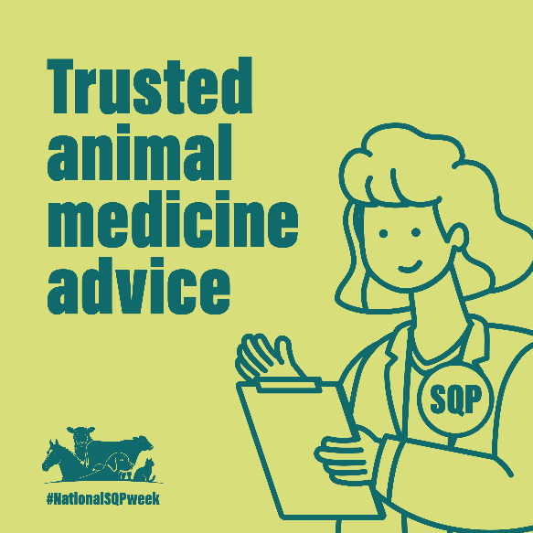
Trusted animal medicine advice
Suitably Qualified Persons (SQPs) also known as Animal Medicines Advisors, are trained and regulated professionals who can supply certain medicines and provide trusted advice on animal medicines. They can recommend and supply suitable treatments for pets, horses and livestock, helping ensure they’re used safely and effectively. This National SQP Week, let’s celebrate that expertise and the importance of this role in supporting owners to keep animals healthy.
#NationalSQPweek #AnimalCare #PetHealth #EquineCare #LivestockCare #PetCare

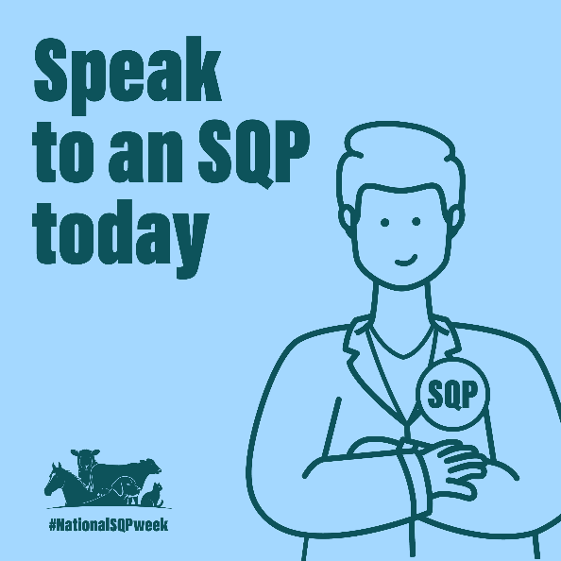
Speak to an SQP today
Speak to a Suitably Qualified Persons (SQP) also known as Animal Medicines Advisors, for advice tailored to your animal’s needs. From parasite control to general care across pets, livestock, horses and birds, they can help you make informed decisions about the right treatments. This National SQP Week, let’s celebrate their expertise and the importance of this role in supporting owners to keep animals healthy.
#NationalSQPweek #AnimalCare #PetHealth #EquineCare #LivestockCare #PetCare

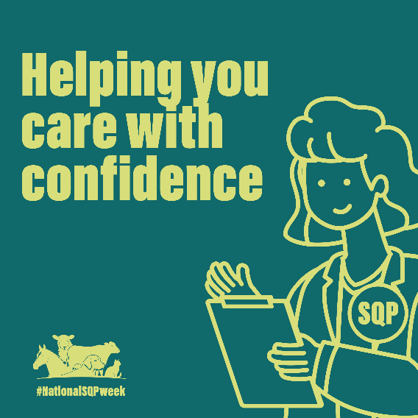
SQPs - Helping you care for your animals with confidence
Suitably Qualified Persons (SQPs) also known as Animal Medicines Advisors, support responsible medicine use by helping you choose the most appropriate treatments for your animals. And when an animal needs a diagnosis or a vet-only medicine, they’ll make sure you are directed to a vet. SQP training and knowledge helps ensure responsible medicine use and better animal welfare. This National SQP Week, let’s celebrate that expertise!
#NationalSQPweek #AnimalCare #PetHealth #EquineCare #LivestockCare #PetCare

