Client/customer/colleague SQP factsheet
How to Use This Document
This SQP factsheet can be used in newsletters, training sessions, social media posts, or as part of a fun quiz or competition.
If you choose to run a quiz:
- Read the customisation section at the end of the document.
- Add your organisation’s details, including your chosen prize, entry process, and privacy wording.
- Remove any placeholder text before sharing with your audience – that’s all text in BLUE
- Add your organisation’s branding (logo, colours, contact details) if appropriate

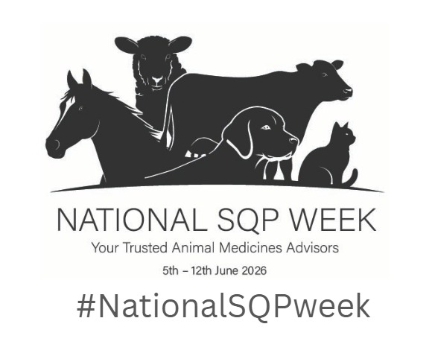

SQP Fun Factsheet
A Suitably Qualified Person (SQP), also known as Animal Medicines Advisors, are trained and regulated professionals who help owners make safe, responsible decisions about medicines and provide vital advice on animal wellbeing for their animals.
Did You Know that….
- SQPs help guide responsible treatment choices
- SQPs advise on responsible medicine use
- SQPs can prescribe, dispense and supply certain medications for pets, horses, birds and livestock
- If SQPs feel an animal needs to see a vet, they will direct owners to a veterinary professional.
- SQPs are trusted, regulated, professionals who complete accredited qualifications and ongoing CPD
Why SQPs matter
- SQPs support animal welfare.
- SQPs promote responsible medicine use.
- SQPs help owners make confident, informed decisions about animal health and wellbeing.
- SQPs provide accessible advice in shops, vet practices, and online.
- SQPs are trusted regulated professionals who are qualified and complete ongoing training.
How many of these facts did you know?
☐ All
☐ Around half
☐ A few
☐ Hardly any
☐ None
#NationalSQPweek
Customisation Required – Running a quiz or competition?
If you plan to use this Fun Fact Sheet as a quiz or competition, please customise this section so it reflects your organisation’s policies. You should replace the placeholder text below with:
- Provide a space for entrants to leave their contact details
- Your data protection or privacy statement (how you will collect, store and use participants’ information).
- Details of the prize you intend to offer (e.g., a discount voucher, small gift, or other workplace-appropriate reward).
- How people enter and how the winner will be selected (e.g., random draw, fastest correct answers, etc.).
Alternatively, you can simply use this as a fun quiz which you can hand out to customers by printing copies off or gather your team together over lunch and run it as a lunchtime quiz as part of your National SQP Week activities. You could also use the content on your social media channels.

